##### **Sustainable Supply Chain Performance in Power BI**

**An Overview:**

* Power BI is a data visualization tool designed to monitor, measure, and optimize the environmental, social, and economic aspects of a supply chain. A Sustainable Supply Chain Performance Dashboard is a tool designed to track and analyse the sustainability of a company’s supply chain operations. Here, we use Power BI dashboard to integrate key metrics such as product type, availability, order quantity, cost, revenue generated, stock levels and etc.

**Steps:**

1. Power BI Installation:

* Use the below link or search for Power BI in your browser. Select your desired language and click download. Complete the Installation process.
* <https://www.microsoft.com/en-us/download/details.aspx?id=58494>

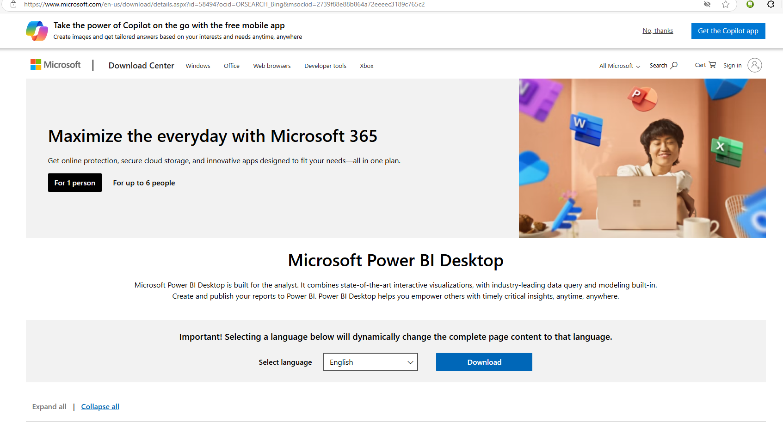

1. Open Power BI canvas:

* Open Power BI and open ‘blank report’ to go to canvas page.

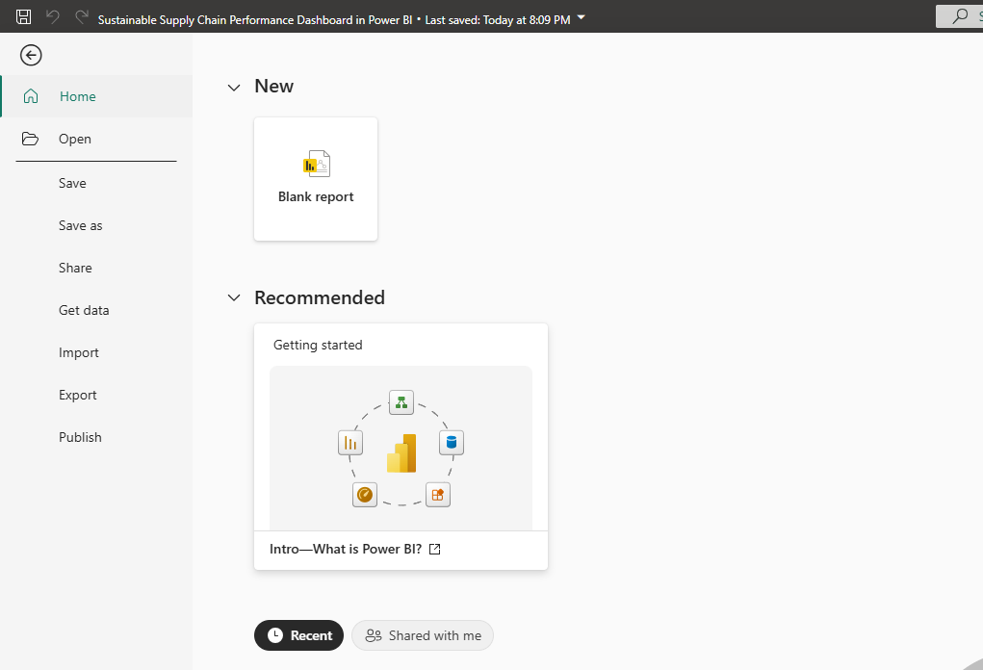

1. Upload Data File:

* Click on ‘get data’ and choose the type of file such as csv.

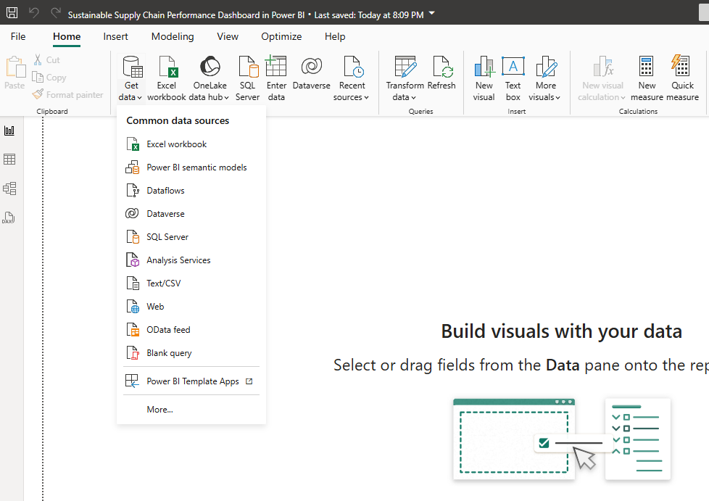

1. Load the Data:

* Choose the respected csv file and click load the data.

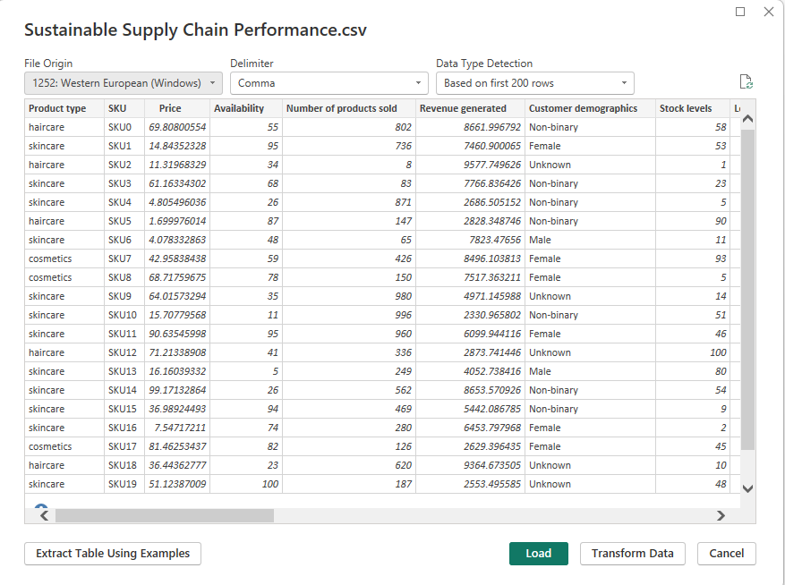

1. Open in Object Query Editor:

* Click on ‘Transform Data’ to open Query Editor.

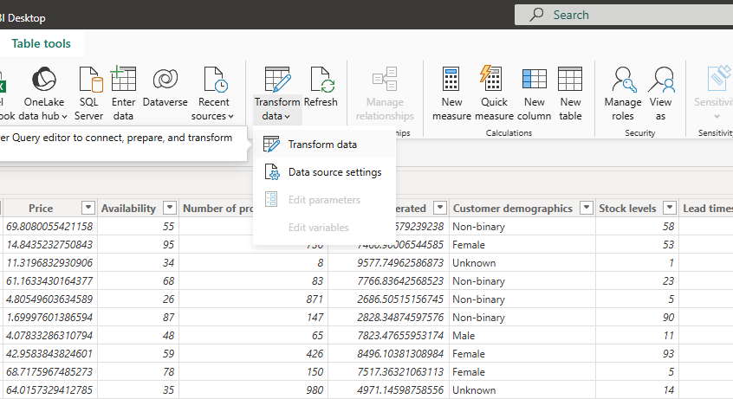

1. To create separate tables:

* Create duplicates and rename the query as per their respective table names.

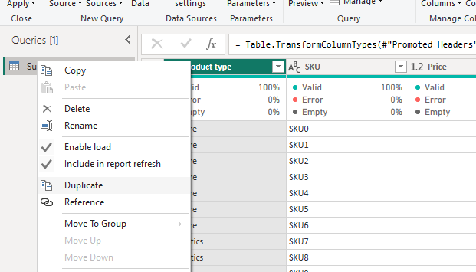

1. To delete columns:

* In the duplicated query, select the columns to be deleted (use ctrl key to choose more than one column) and click on ‘remove columns’ to remove the columns.

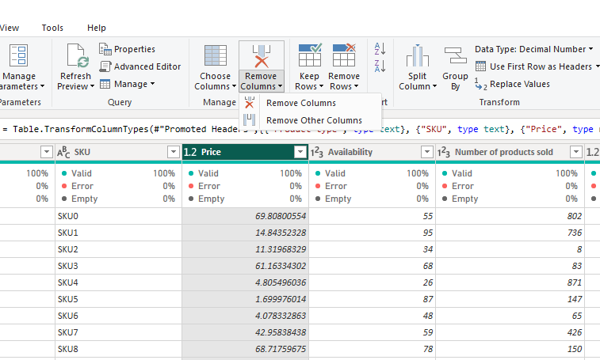

1. To save changes:

* Use Close and Apply option to reflect changes in canvas (also to save changes).
* Next, using save as option you can save the file to your device.

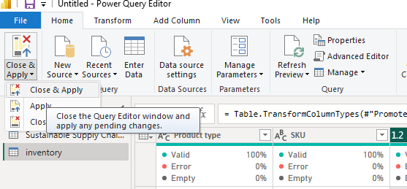

**Conclusion:**

By end of the project Sustainable Supply Chain Performance in Power BI, We will have a simple and effective dashboard for companies to maintain their supply chains.